**Name: Adithya M SRN: PES1UG20CS621 Section: K  
DBT Assignment 1**

**ER Diagram:**

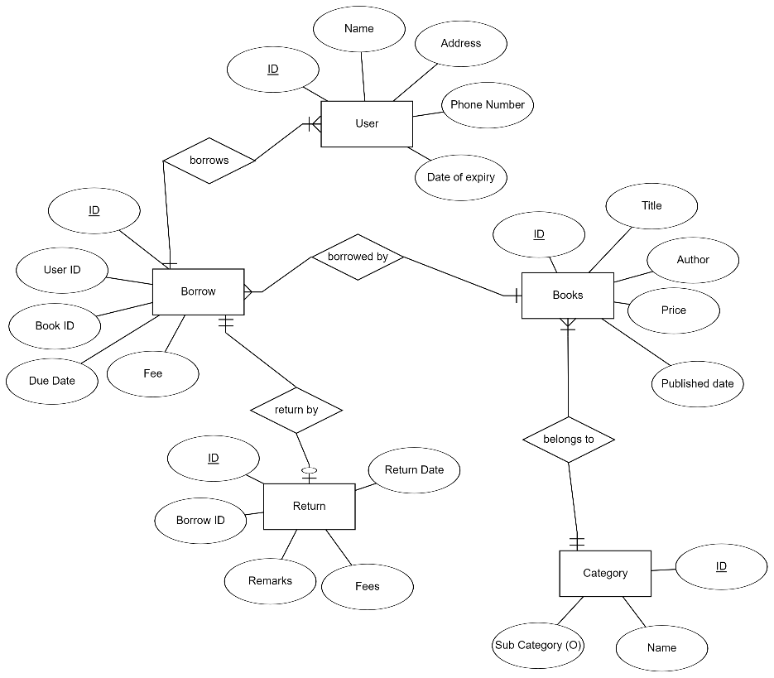

**Relational Schema:**

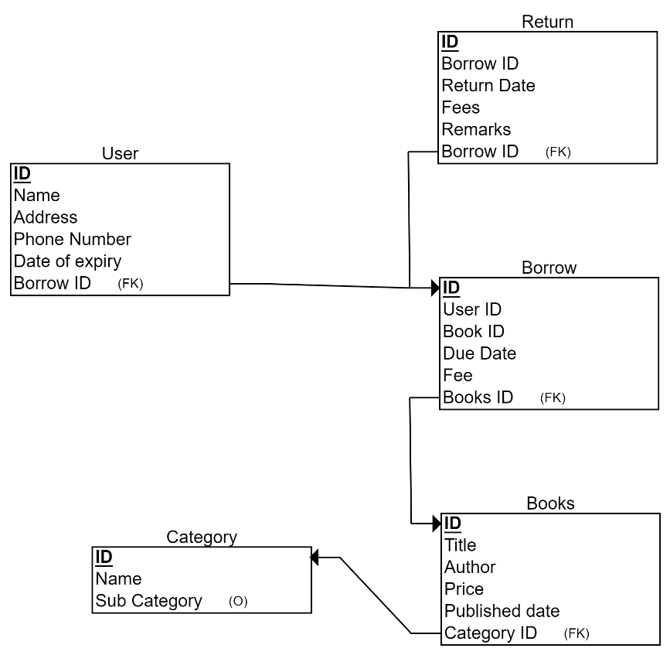

**Tables**:

SELECT * FROM books;

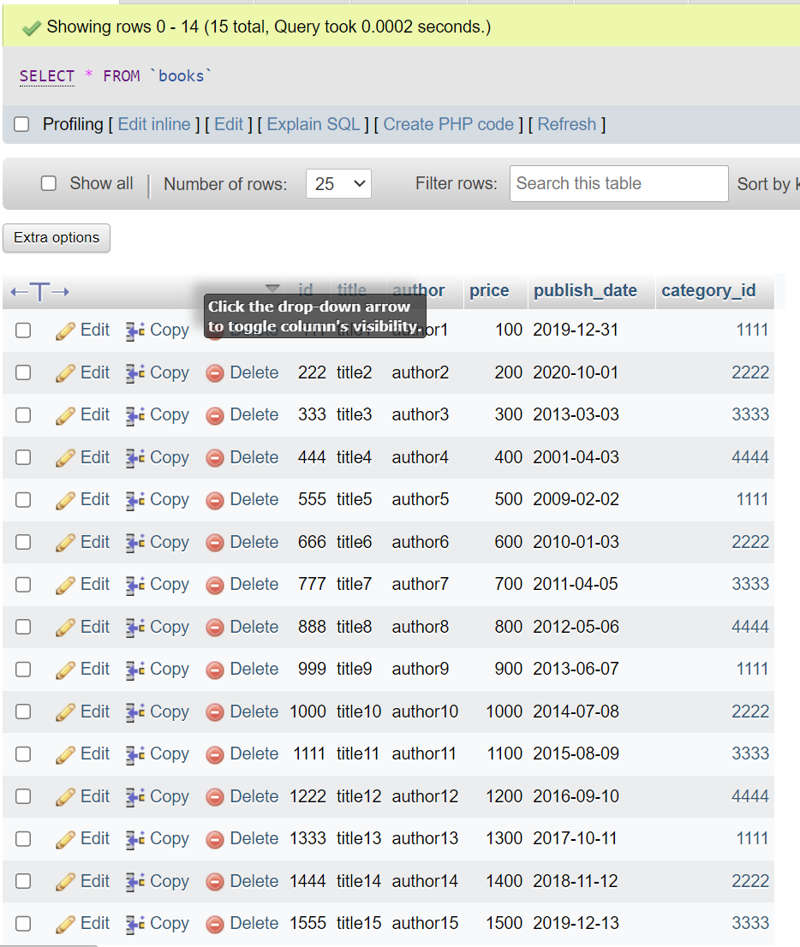

SELECT * FROM borrow;

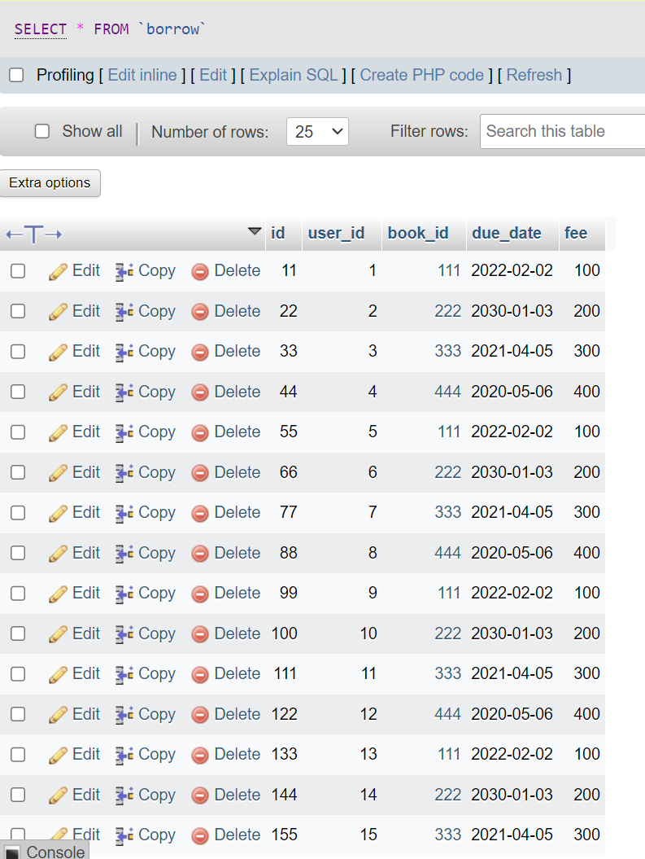

SELECT * FROM category;

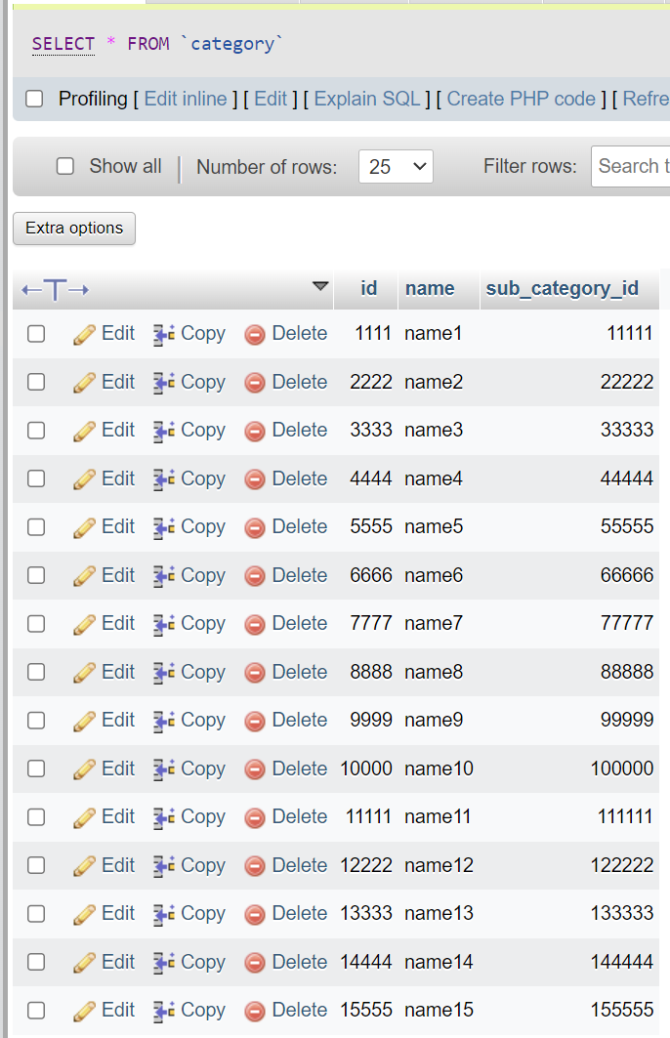

SELECT * FROM returns;

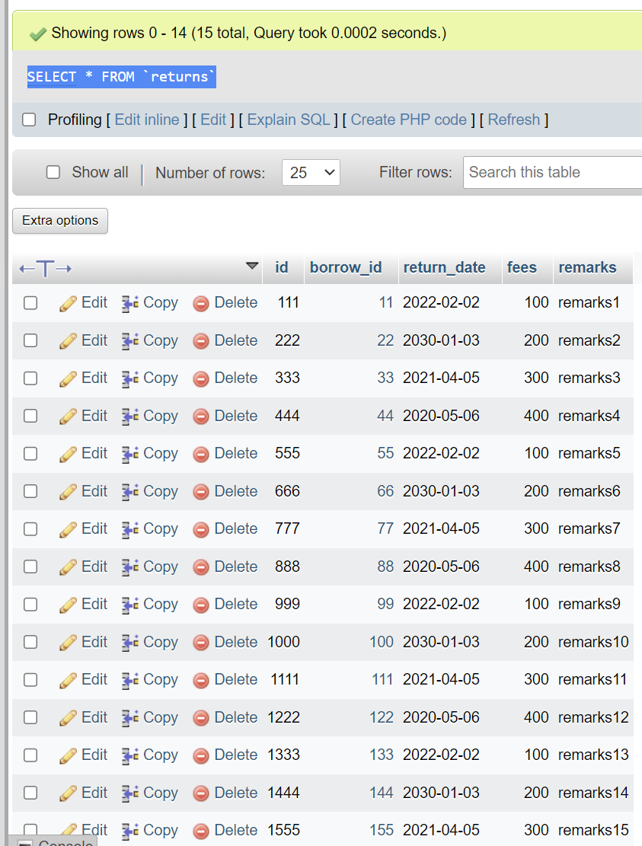

SELECT * FROM user;

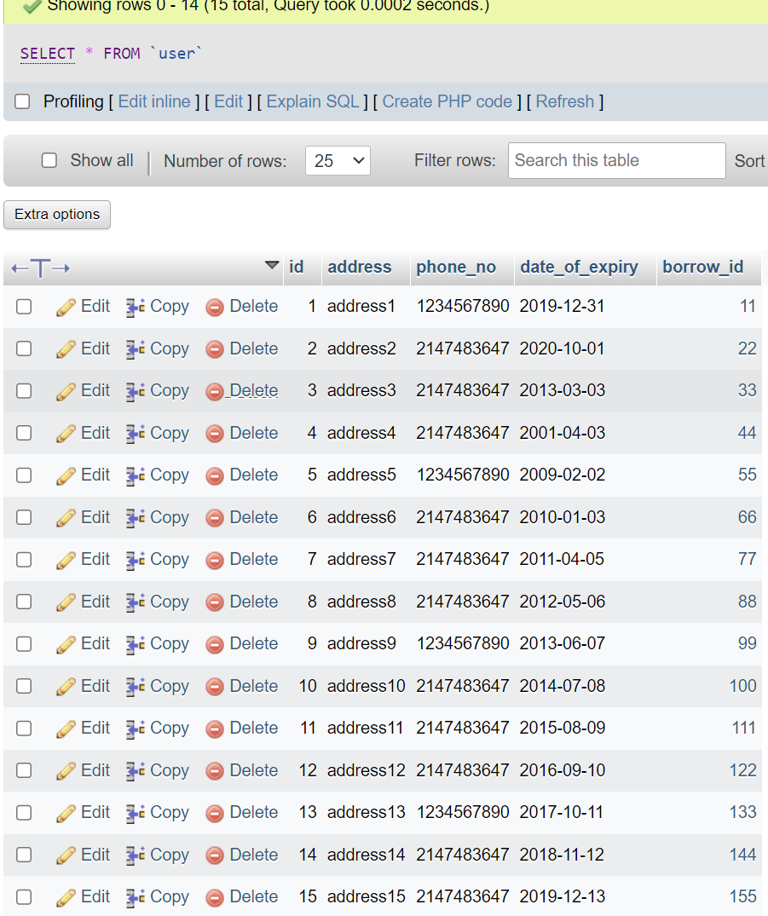

**Creating indices**

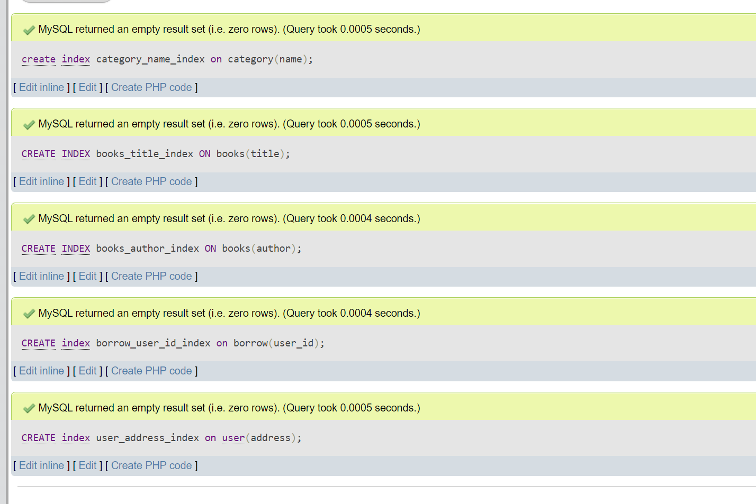

**Queries**  
1) SELECT b.title, b.author FROM books b JOIN category c ON b.category_id = c.id WHERE c.name = 'name1';

Without index:

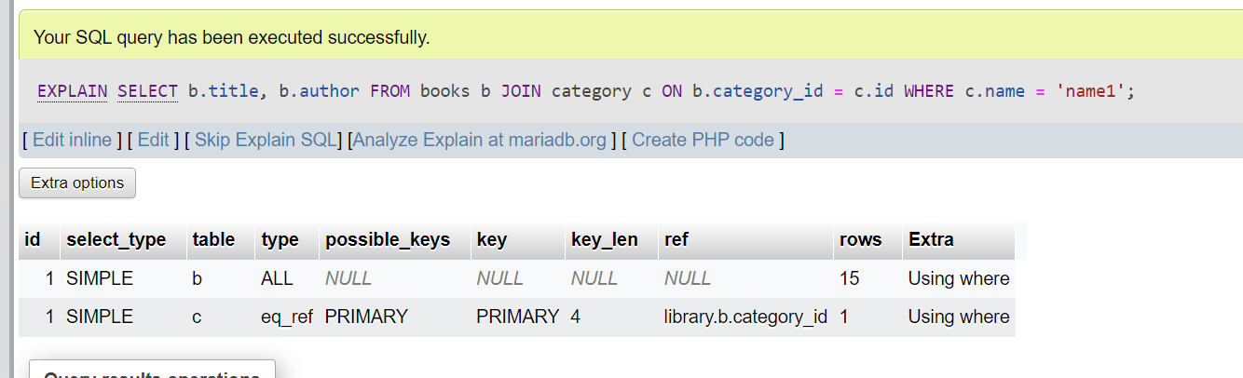

With Index:

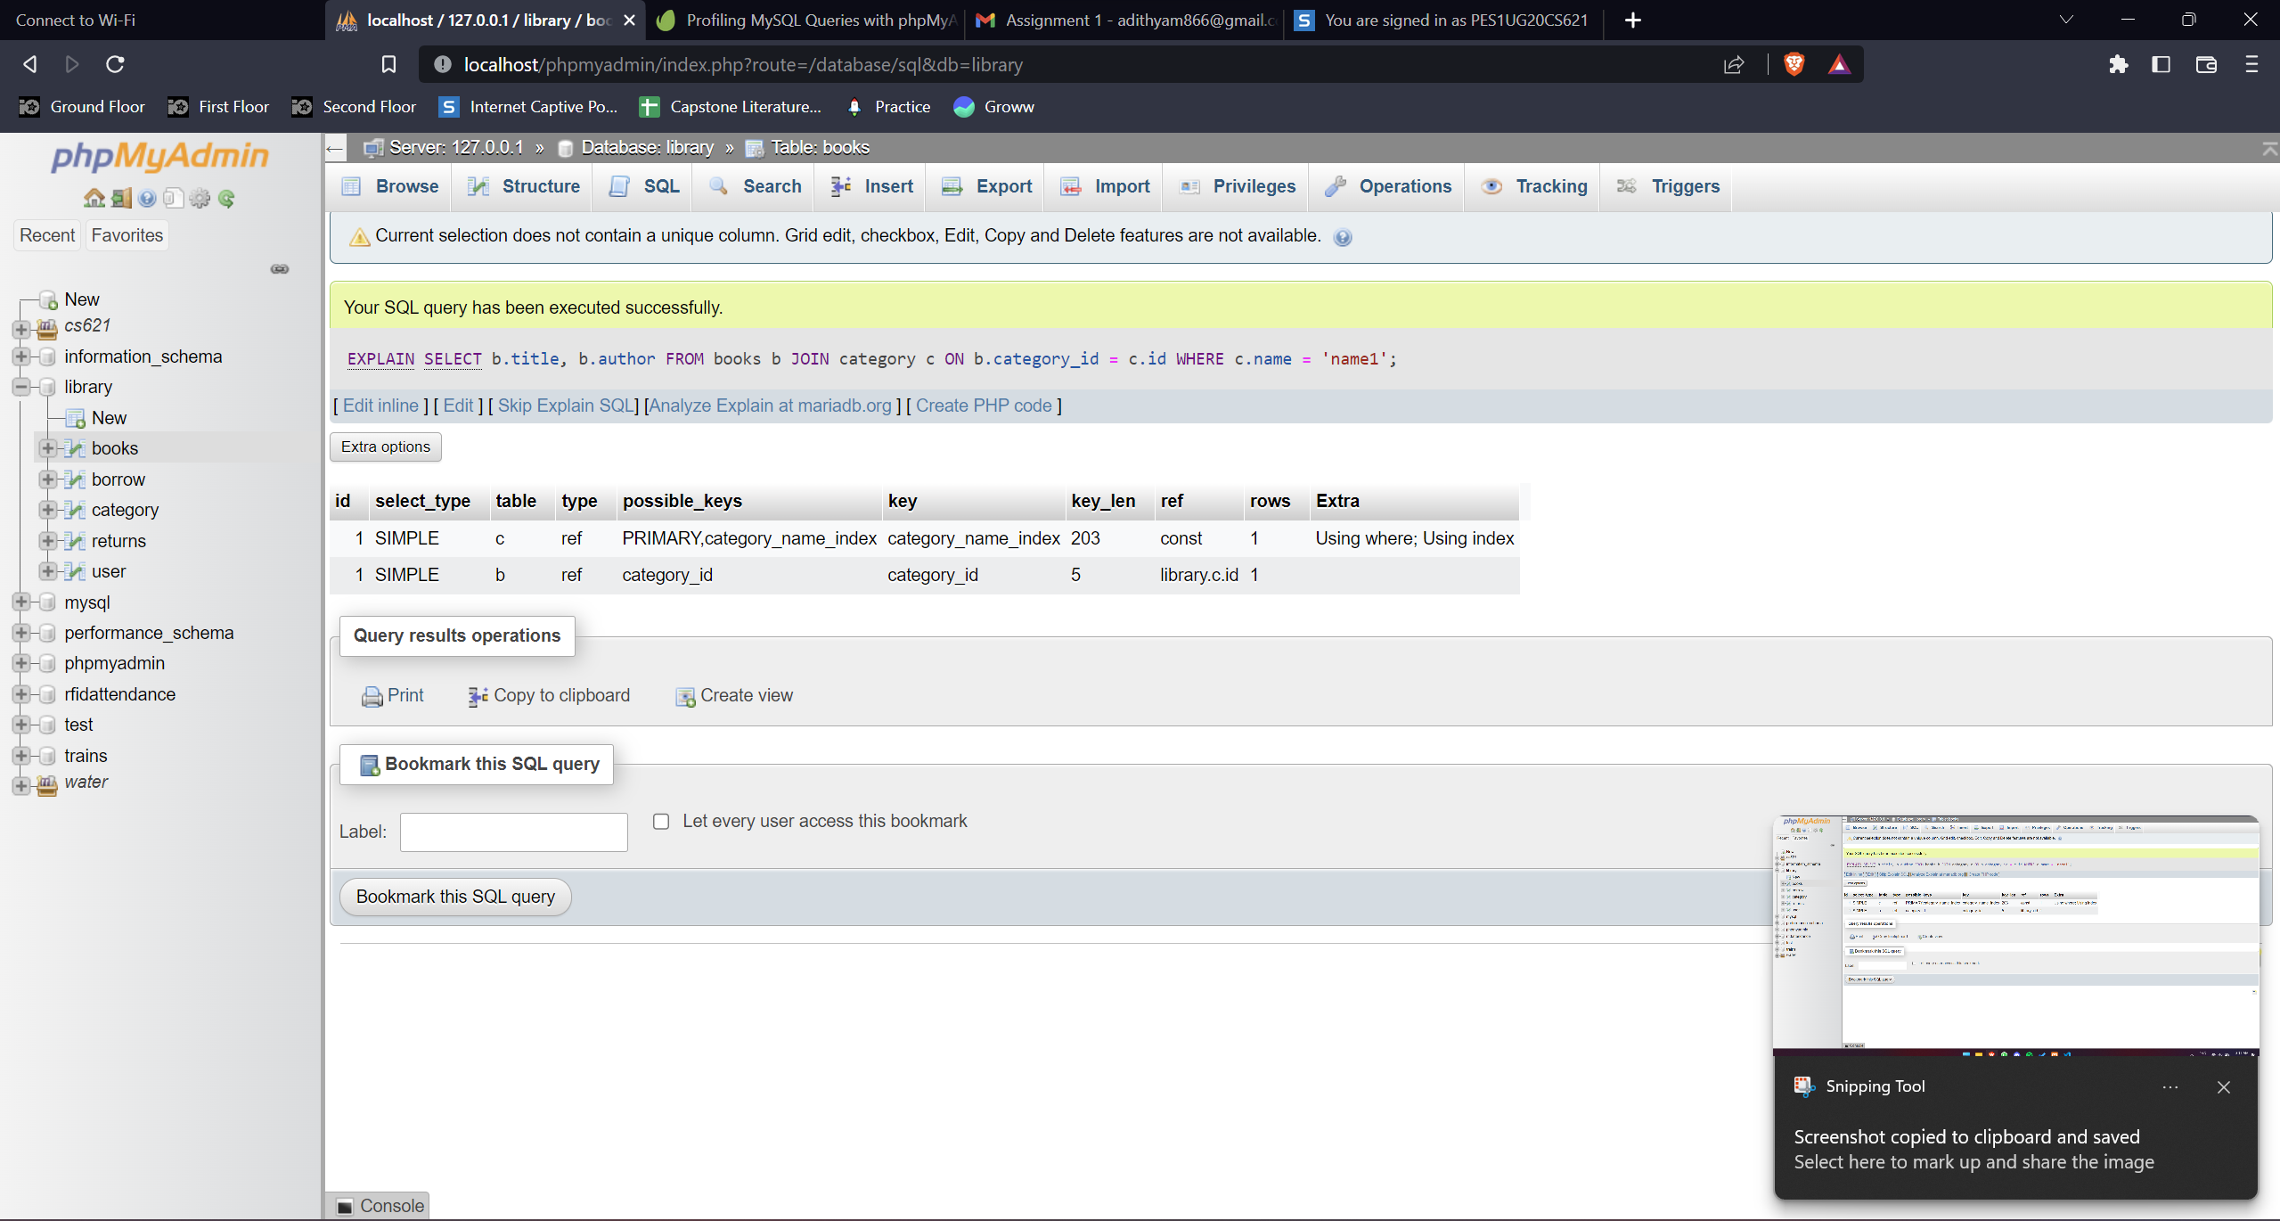

2) SELECT * FROM borrow WHERE user_id = 111 AND book_id between 1 and 110;

Without index:

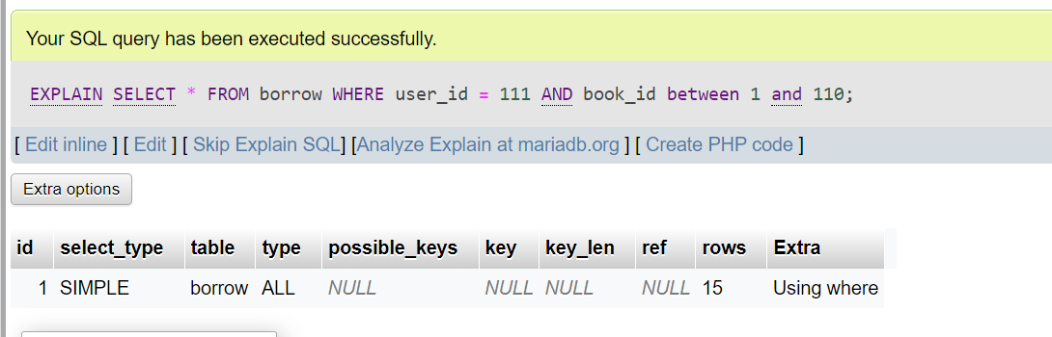

With index

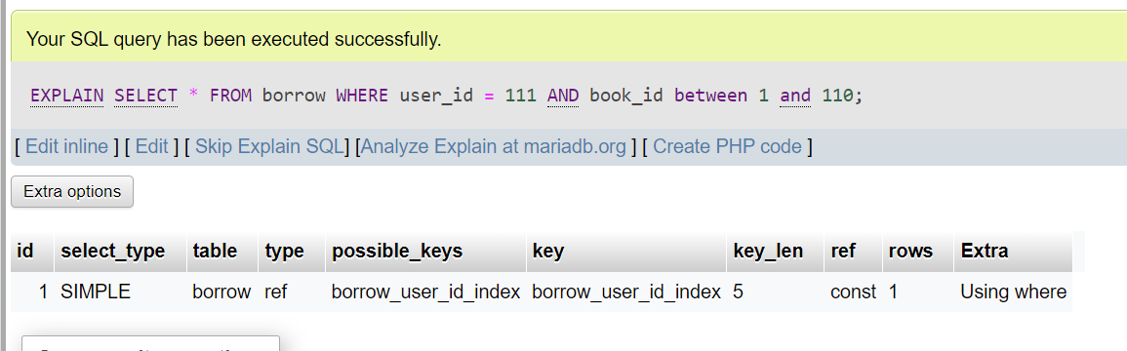

3) SELECT * FROM returns WHERE borrow_id IN (SELECT id FROM borrow WHERE user_id = 111 AND book_id between 1 and 110);

Without index:

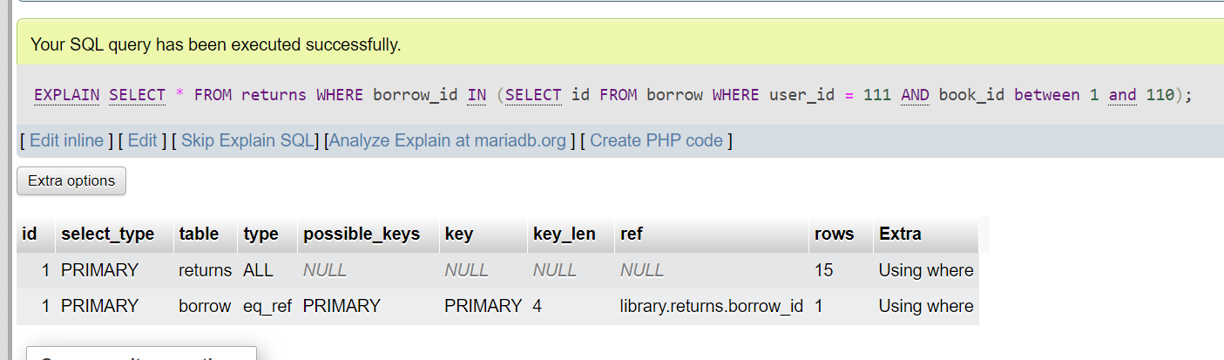

With index:

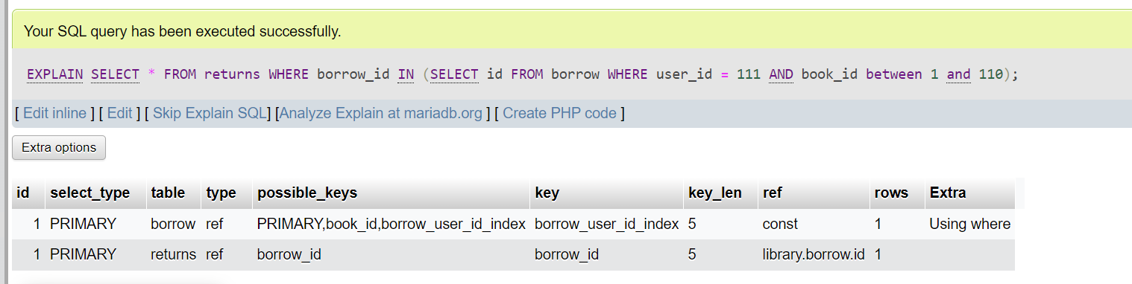

4) SELECT * FROM books WHERE price/5 > 100 AND price/5 < 200;

Without optimization (index present):

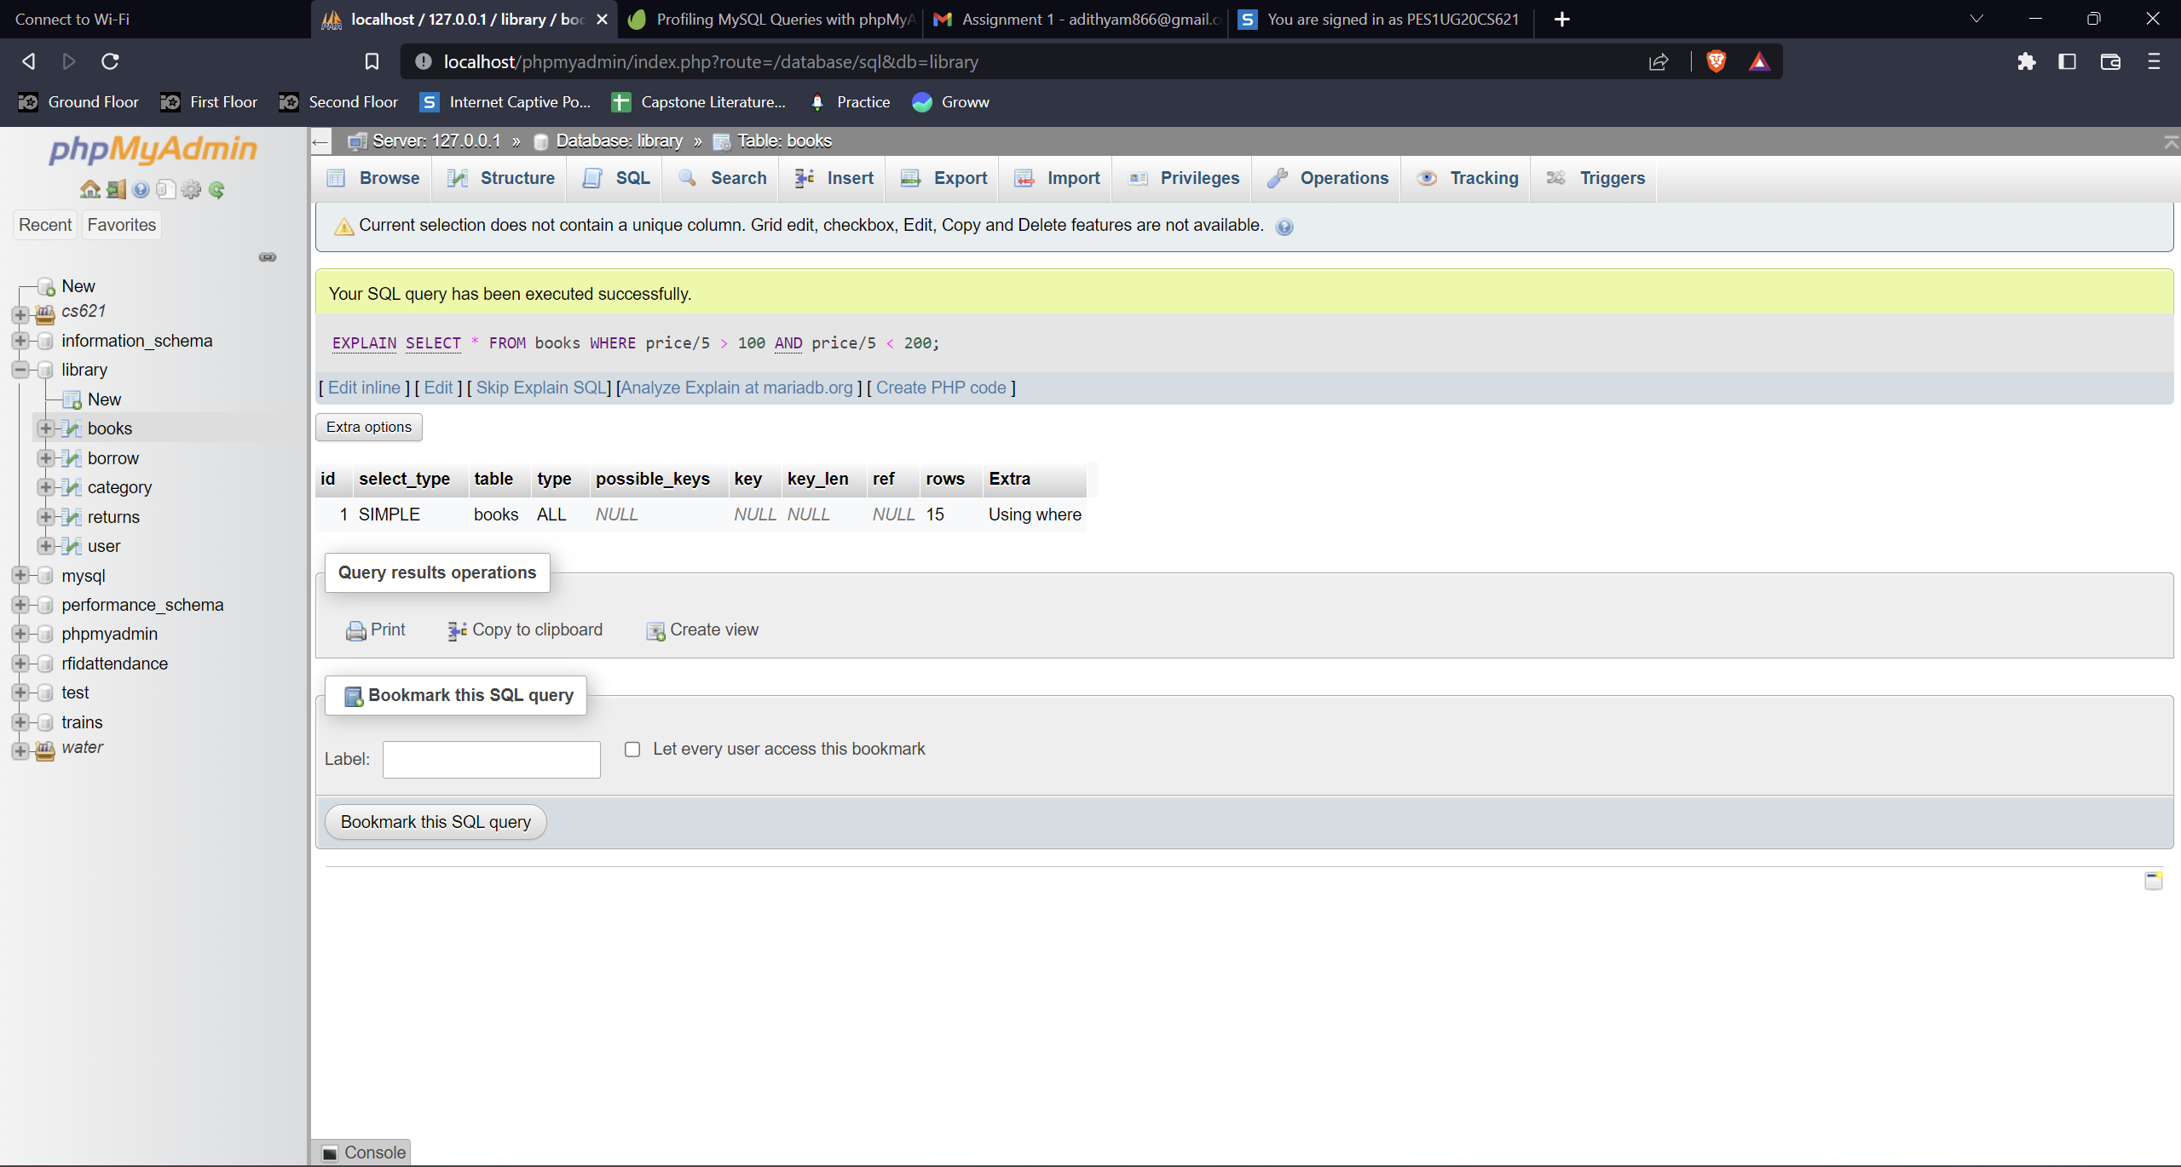

With optimization (index present):

SELECT * FROM books WHERE price > 500 AND price < 1000;

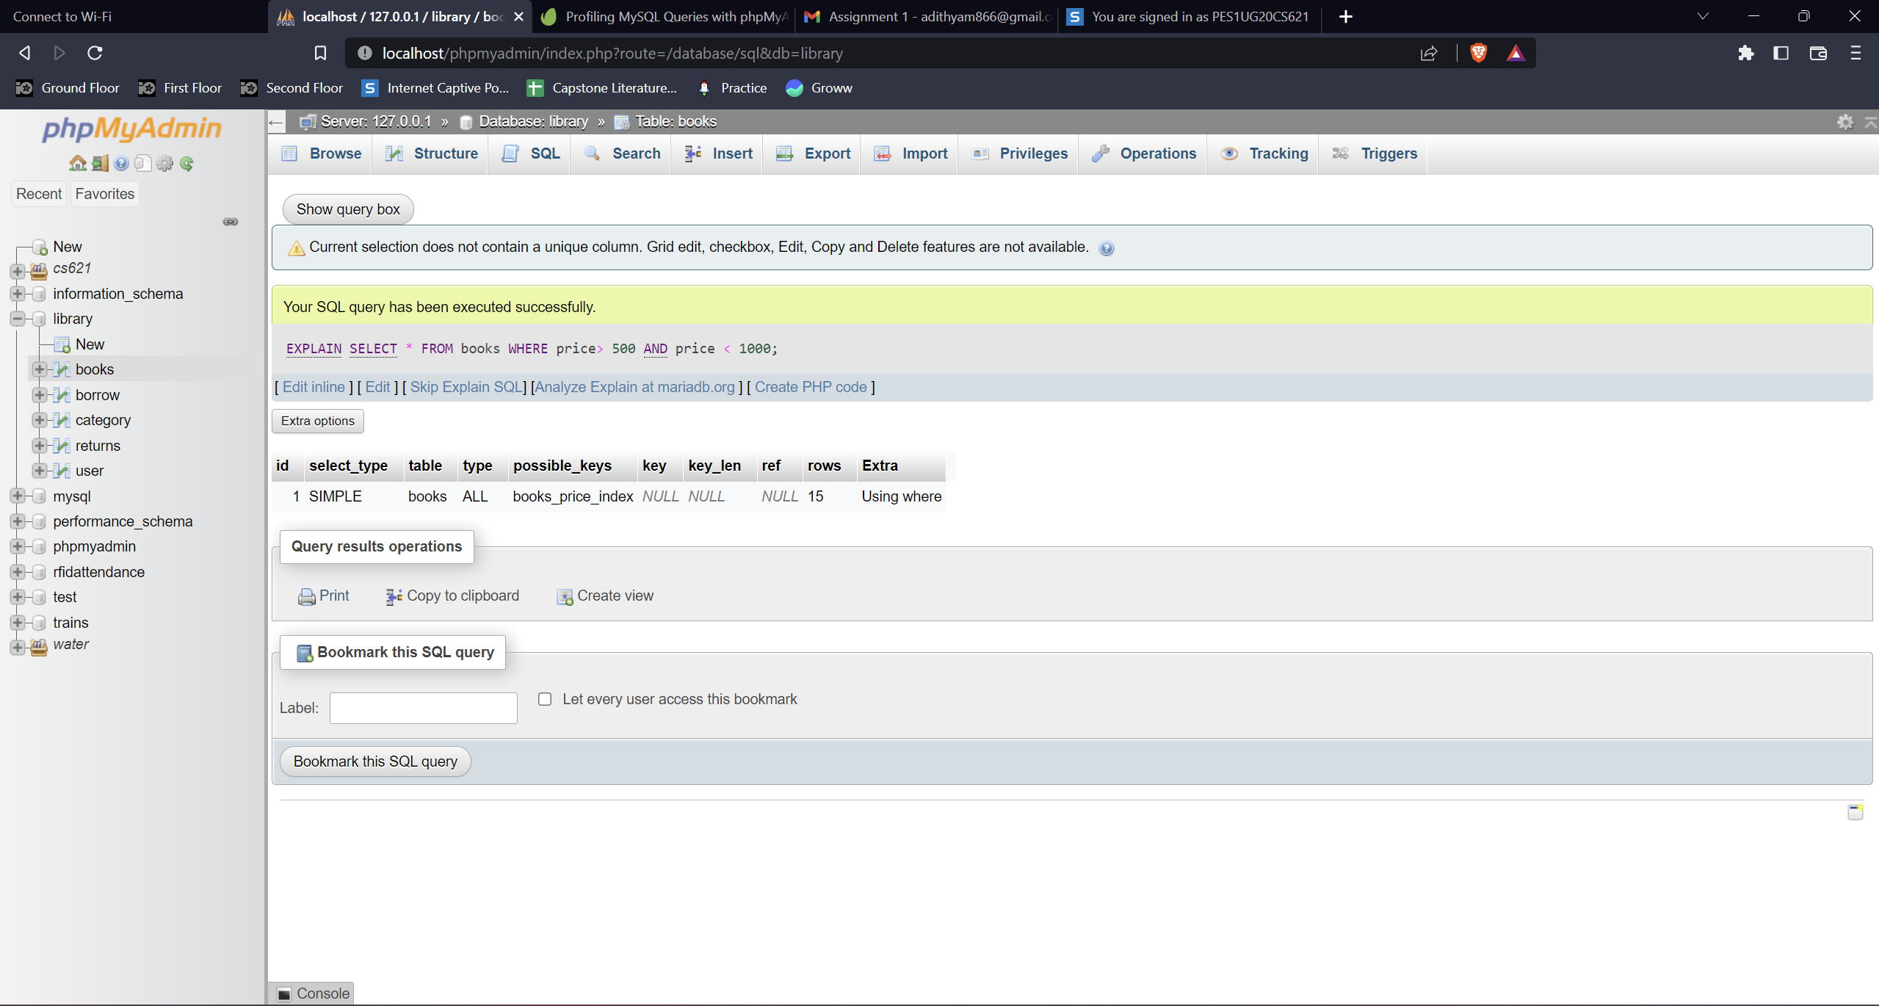

5) SELECT * FROM books WHERE YEAR(publish_date) = 2022;

Without index and optimisation:

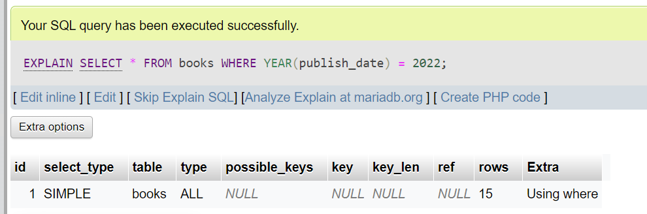

Creating index: CREATE INDEX books_publish_date_index ON books(publish_date);

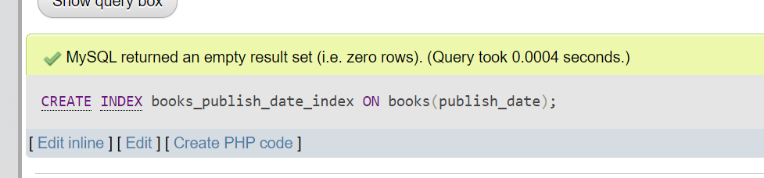

Optimised query: SELECT * FROM books WHERE publish_date >= '2022-01-01' AND publish_date < '2023-01-01';

